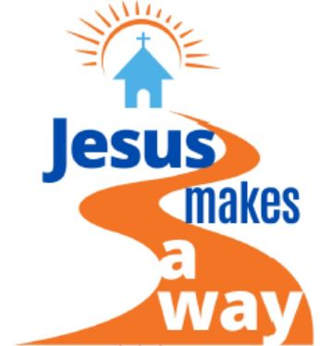
2021 Church
Conference Agenda
Jesus Makes a Way

Call to Order

Opening Prayer (Pastor or Lay leader)

Hymn

Scripture Mark 4: 35-41

Message (District Superintendent or Presiding Elder)
Reflections on the past year with references to some of the ways the Annual Conference has adapted and carried out ministry in the new paradigm and through the storms we weathered.

Open Discussion

- What are some of the storms your church faced this past year?
- How have you seen Jesus being a “way maker” for your church?
- Where is Jesus calling your church to help others this next year?

Celebration of Ministries

Hymn

Business of Charge Conference

- Lay Nominations Report
- Clergy Compensation
- Other Reports

Closing Prayer and Benediction (Pastor)

