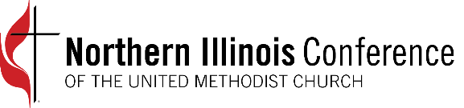

Worship with the NIC Cabinet
Eastertide 2021

Message: “More than Enough”
Jesus comes to us in our abundance as well as in our brokenness.
Jesus goes ahead of us and we find him in our blessings.

Opening Music “Thine be the Glory” UMH #308

Welcome and Greeting Rev. Brian Gilbert
DeKalb District Superintendent

Opening Prayer Rev. J. Martin Lee
Director of Congregational Development and Redevelopment

Eastertide Music “A Mighty Fortress” UMH # 110

Children’s Time Rev. Arlene Christopherson, Assistant to the Bishop and
Director of Connectional Ministries

Scripture Reading John 21: 1-14 (CEB)
Rev. Darneather Murph-Heath
Elgin District Superintendent

Sermon “More than Enough” - Bishop John Hopkins

Testimony Rev. Jeffry Bross
Aurora District Superintendent

Invitation to Offering Rev. Fabiola Grandon-Mayer
and Prayer Rockford District Superintendent

Music “Come All Ye People” TFWS #2274

Prayers for the People Rev. Brittany Isaac
Chicago Northwestern District Superintendent

benediction Rev. Jacques Conway
Chicago Southern District Superintendent

Closing Music “God of Grace and God of Glory” UMH #577

CCLI #20540936, #E1459355

