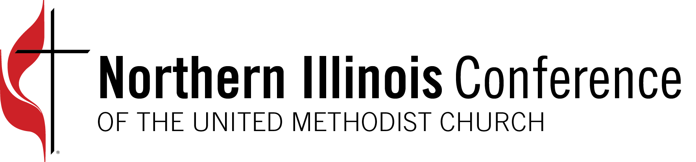

Congratulations! The Northern Illinois Conference celebrates (name of church) for faithfully paying 100% of its apportionments in 2022. Bishop Dan Schwerin gives thanks to all the Northern Illinois churches that stepped up and made connectional giving a priority despite these challenging times.

“The 2022 report on apportionments is a witness to this strength and deeply rooted understanding of God’s abundance,” commented Bishop Schwerin.

“Thank you for all you are doing to make disciples of Jesus Christ for transforming the world in your local communities, the NIC, and The UMC,” said Rev. Tammy Scott, CCFA chair. “Together, we are reaching new people, changing lives, and shining the light of Christ into the world.”

Your apportionment dollars help support hundreds of global and local ministries and missions throughout our United Methodist connection. Thank You!

